**Project Title:LISTNER - AI-based Life Assistance Chatbot Integration for public welfare**

**Project Report Titles**

1 **INTRODUCTION**

* 1. Overview

A brief description about your project

* 1. Purpose

the use of this project. What can be achieved using this.

2 **LITERATURE SURVEY**

2.1 Existing problem

Existing approaches or method to solve this problem

2.2 Proposed solution

What is the method or solution suggested by you?

3 **THEORITICAL ANALYSIS**

3.1 Block diagram

Diagrammatic overview of the project.

3.2 Hardware / Software designing

Hardware and software requirements of the project

4 **EXPERIMENTAL INVESTIGATIONS**

Analysis or the investigation made while working on the solution.

5 **FLOWCHART Diagram**

Showing the control flow of the solution

6**ADVANTAGES & DISADVANTAGES**

List of advantages and disadvantages of the proposed solution

7**APPLICATIONS**

The areas where this solution can be applied

8**CONCLUSIONS**

Conclusion summarizing the entire work and findings.

9**FUTURE SCOPE**

Enhancements that can be made in the future.

Project Report Titles

10**BIBILOGRAPHY**

References of previous works or websites visited/books referred for analysis about the project, solution previous findings etc.

**APPENDIX**

1. Source Code

Attach the code for the solution built.

11**RESULTS**

Final findings (Output) of the project along with screenshots.

**1 INTRODUCTION**

* 1. Overview

LISTNER is an AI-based Life Assistance Chatbot designed for integration into various public welfare initiatives. It serves as a virtual conversational agent that utilizes artificial intelligence and natural language processing to provide assistance and support to individuals in need. The primary objective of LISTNER is to enhance the accessibility and availability of crucial information and services related to public welfare.By integrating LISTNER into public welfare initiatives, organizations and governments aim to offer a user-friendly and efficient platform for citizens to access essential resources, guidance, and support. This AI-powered chatbot can handle a wide range of inquiries and tasks, such as providing information about government programs, social services, healthcare resources, emergency assistance, educational opportunities, and more.

It operates 24/7, ensuring that users can access assistance whenever they need it. It also reduces the burden on human staff by handling routine inquiries, allowing human resources to focus on more complex tasks. Moreover, LISTNER can reach a wider audience, including those who might be more comfortable interacting with technology than seeking help through traditional channels.

Overall, LISTNER represents a significant step toward leveraging AI technology to enhance the accessibility, efficiency, and effectiveness of public welfare services.

**1.2 Purpose**

The purpose of implementing the LISTNER AI-based Life Assistance Chatbot integration for public welfare is to accomplish several important objectives and benefits:1. Enhanced 1.**Accessibility**: The project aims to make vital information and services related to public welfare easily accessible to a wide range of individuals. The chatbot serves as a user-friendly interface, allowing users to obtain information without the need for specialized knowledge or navigating complex systems.

2. **24/7 Availability**: LISTNER operates around the clock, providing assistance at any time of day. This ensures that individuals can receive help, guidance, and information whenever they need it, even outside of regular office hours.

3. **Efficiency and Scalability**: By automating routine inquiries and tasks, the chatbot streamlines processes and reduces the burden on human staff. This efficiency allows organizations to handle a larger volume of queries and serve a larger number of citizens effectively.

4. **Personalized Assistance**: LISTNER's AI capabilities enable it to understand user preferences and needs. It can offer tailored recommendations and solutions, enhancing the quality of assistance provided.

5. **Quick Information Retrieval**: The chatbot can swiftly retrieve up-to-date information from databases and resources, enabling users to access accurate and relevant details promptly.

6. **Public Awareness and Education**: The project can serve as an educational tool, informing citizens about available government programs, social services, healthcare options, and more. This can help raise awareness and encourage individuals to make informed decisions about their well-being.

7. **Resource Optimization**: By automating routine tasks, LISTNER frees up human resources to focus on more complex and specialized tasks that require human expertise and intervention.

8. **Emergency Support**: LISTNER can provide crucial information during emergencies, such asguiding users to emergency services, disaster relief information, or safety protocols.

9. **Continuous Improvement**: The chatbot's interactions can provide valuable insights intouser needs and trends, which can be used to improve public welfare services over time.

10. **Cost-Effectiveness:** While there are initial development and implementation costs, AI chatbots like LISTNER can ultimately offer cost savings by reducing the need for extensive human support for routine tasks.

In summary, the LISTNER AI-based Life Assistance Chatbot integration serves to democratize access to public welfare resources, streamline information dissemination, and provide personalized support to citizens. It aligns with the digital age by harnessing AI technology to enhance public welfare initiatives' effectiveness and impact.

2 **LITERATURE SURVEY**

2.1Existing problem

Several existing approaches and methods are employed to address the challenge of integrating AI-based chatbots, like LISTNER, into public welfare initiatives. These approaches leverage various technologies and strategies to ensure effective deployment and user engagement:

1.**Natural Language Processing (NLP) Techniques**: NLP is a cornerstone for developing chatbots that can understand and generate human-like language. Techniques like sentiment analysis, intent recognition, and named entity recognition help the chatbot comprehend user queries and respond appropriately.

2.**Machine Learning Algorithms**: Machine learning algorithms are used to train chatbots on large datasets, enabling them to learn patterns and improve their responses over time. Reinforcement learning, supervised learning, and unsupervised learning techniques contribute to the chatbot's ability to provide accurate information.

3.Knowledge Graphs: Integrating a knowledge graph allows the chatbot to access structured information and relationships, enhancing its ability to provide contextually relevant responses.

4.**Dialog Management Systems**: Implementing dialog management systems helps the chatbot maintain coherent and meaningful conversations. Techniques like state machines and rule-based systems control the flow of conversation.

5.**Intent Recognition Models**: Developing intent recognition models enables the chatbot to understand the user's purpose and respond accordingly. This involves training the chatbot to recognize various intents or goals behind user queries.

6.**Data Integration**: Integrating the chatbot with relevant databases, APIs, and external sources of information ensures that it can provide accurate and up-to-date responses.

7.**User Profiling and Personalization**: Developing user profiles and personalization algorithms enables the chatbot to offer tailored recommendations and solutions based on historical interactions and user preferences.

8.**Human-Agent Hybrid Model**: Some systems employ a human-agent hybrid model, where the chatbot handles routine inquiries and transfers more complex or sensitive cases to human agents

**.9.Multilingual Support**: Developing multilingual capabilities enables the chatbot to cater to a diverse user base and provide assistance in multiple languages.

10.**Security and Privacy Measures**: Ensuring the chatbot handles sensitive information securely and adheres to privacy regulations is crucial for user trust.

These approaches, often used in combination, contribute to the successful integration of AI-based chatbots like LISTNER into public welfare initiatives. The effectiveness of the chosen approach depends on factors such as the target audience, the complexity of inquiries, available resources, and the goals of the initiative.

**2.2 Proposed solution**

The integration of the LISTNER AI-based Life Assistance Chatbot into public welfare initiatives can be approached using a combination of natural language processing (NLP) techniques, machine learning algorithms, and a human-agent hybrid model. Here's a suggested method:

1.**Natural Language Processing (NLP) Techniques**:

Utilize NLP techniques to enable LISTNER to understand and generate human language effectively. Implement the following:

* Intent Recognition: Train the chatbot to accurately identify user intents to provide relevant assistance.
* Named Entity Recognition: Enable the chatbot to extract specific information such as dates, locations, and names from user queries.

2.**Machine Learning Algorithms**:

Employ machine learning algorithms to improve LISTNER's responses over time. This involves:

* Supervised Learning: Train the chatbot on a labeled dataset of user interactions to enhance its understanding and response generation.
* Reinforcement Learning: Implement reinforcement learning to allow the chatbot to learn from user feedback and optimize its responses.
* Continuous Learning: Enable the chatbot to adapt and improve through ongoing interactions, incorporating user feedback to refine its performance.

3.**Data Integration and Knowledge Graphs**:

Integrate LISTNER with relevant databases and knowledge graphs to provide accurate and up-to-date information:

* Knowledge Graph Access: Enable the chatbot to access structured information and relationships from a knowledge graph to enhance response accuracy.
* API Integration: Connect the chatbot to external APIs to retrieve real-time data and information.

**4User** Profiling **and Personalization**:

Implement user profiling and personalization techniques to enhance user engagement:

* User History: Maintain a user profile to track historical interactions and preferences.

Personalized Recommendations: Utilize user profiles to offer tailored recommendations and solutions.

5.**Security and Privacy Measures**:

Ensure the security of user data and adhere to privacy regulations:

* Data Encryption: Encrypt user data to prevent unauthorized access.

Anonymization: Avoid storing sensitive user information and anonymize data wherever possible.

By combining these approaches, LISTNER can effectively address user inquiries, provide valuable assistance, and contribute to the success of public welfare initiatives by offering accessible and personalized support to individuals in need.

**3 THEORITICAL ANALYSIS**

3.1 Block diagram

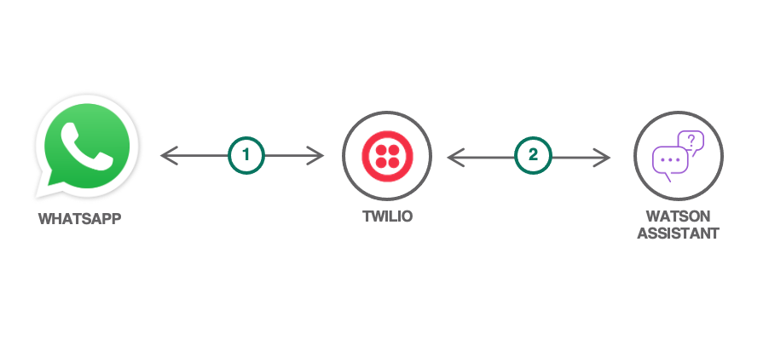

**3.2 Hardware / Software designing**

The hardware and software requirements for the LISTNER AI-based Life Assistance Chatbot project can vary based on factors like the scale of the project, the platform you're targeting, and the specific technologies you plan to use. Below is a general outline of the hardware and software requirements:

**Hardware Requirements**:

1. **Server/Cloud Infrastructure**:

For hosting the chatbot application, you'll need servers or cloud instances with sufficient computing

resources to handle the expected user load**.**

**2. Storage**:

Adequate storage space for storing chatbot data, logs, user interactions, and knowledge base information.

**Software Requirements**:

1.**Programming Languages**:

* Python: Commonly used for AI and NLP development.

2.**API Integrations**:APIs for accessing external data sources like emergency information, government programs, or healthcare resources.

3.**Version Control**:

* Git: For version control and collaborative development.

4.**Deployment and Hosting**:

* Cloud Services: AWS, Azure, Google Cloud, or other cloud platforms for hosting the application.
* Web Server: Nginx or Apache for serving web-based interfaces.

5**. Security**:

SSL/TLS Certificates: For secure communication between users and the chatbot.

Security Practices: Implement best practices for securing user data and preventing vulnerabilities.

6. **Text Editors/IDEs**:Choose a text editor or integrated development environment (IDE) for coding, such as Visual Studio Code, PyCharm, or Jupyter Notebook.

4 **EXPERIMENTAL INVESTIGATIONS**

During the process of developing and implementing the LISTNER AI-based Life Assistance Chatbot integration for public welfare, several crucial analyses and investigations would be undertaken to ensure the success and effectiveness of the solution. Here are some key aspects that would be explored:

1.User Needs Assessment:

Identify the specific needs of the target audience within the context of public welfare. This could involve conducting surveys, interviews, or focus groups to understand the types of information and assistance users require.

2.Technology Feasibility:

Investigate the availability of suitable technologies, tools, and frameworks for implementing natural language processing, machine learning, and chatbot development.

3.Data Availability and Quality:

Analyze the availability and quality of data sources required for training and improving the chatbot's accuracy. Ensure that the data is up-to-date and reliable.

4.API Integration:

Research and select appropriate APIs for accessing external data sources such as government programs, emergency services, healthcare facilities, etc.

5.NLP Model Selection:

Evaluate various NLP models and libraries (NLTK, spaCy, Transformers) to determine the most suitable approach for intent recognition, entity extraction, and dialogue management.

6.Machine Learning Approach:

Choose between supervised learning, reinforcement learning, or a combination of both, based on the project's requirements and available data.

7.Privacy and Security Analysis:

Conduct a thorough analysis of the privacy and security measures required to protect user data and ensure compliance with relevant regulations.

8.Human-Agent Hybrid Design:

Determine the criteria for transferring interactions from the chatbot to human agents. Investigate the process for seamless escalation and handover.

9.User Interface Design:

Design a user-friendly and intuitive interface that caters to the target audience, considering accessibility and ease of use.

10.Personalization Strategy:

Analyze user profiling and personalization techniques to offer relevant and customized responses. Investigate how to balance personalization with user privacy concerns.

Throughout the development process, regular iterations and adjustments would be made based on the insights gained from these analyses. Continuous improvement and refinement would be key as the chatbot interacts with users and gathers real-world data.

**5 . FLOWCHART**

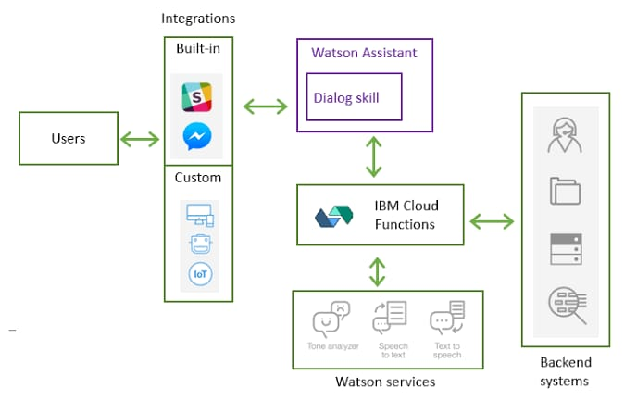

**7. ADVANTAGES & DISADVANTAGES**

Certainly, here's a general list of advantages and disadvantages of AI-based chatbot solutions like LISTNER for public welfare:

Advantages:

**Accessibility:** Chatbots provide 24/7 availability, ensuring users can access information and assistance whenever they need it.

**Efficiency**: Chatbots can handle multiple conversations simultaneously, reducing wait times for users and improving service efficiency.

**Cost Savings**: By automating routine tasks, organizations can reduce labor costs and allocate human resources to more complex tasks.

**Scalability**: Chatbots can handle a large volume of users simultaneously, making them scalable for growing user bases.

Consistency: Chatbots provide consistent responses, avoiding human errors and ensuring uniform information delivery.

**Quick Information Retrieval**: Chatbots can swiftly access and provide accurate information from databases and external sources.

**Personalization**: With user profiling, chatbots can offer tailored recommendations and solutions, enhancing user experience.

**Data Collection**: Interaction data can provide valuable insights into user behavior, preferences, and trends, aiding decision-making.

Disadvantages:

**Lack of Human Understanding**: Chatbots might struggle to understand the nuances of complex or emotionally charged queries, leading to frustrating interactions.

**Data Dependency**: Chatbot accuracy relies on the quality and accuracy of the data it has been trained on and its access to current data sources.

**Initial Development Costs**: Designing and implementing a chatbot solution requires initial investment in technology, training, and integration.

**Technical Complexity**: Developing and maintaining chatbots requires expertise in natural language processing and machine learning.

8 **APPLICATIONS**

The LISTNER AI-based Life Assistance Chatbot integration for public welfare can be applied to various areas where there is a need for accessible information, support, and assistance. Some potential application areas include:

**Government Services and Programs**: The chatbot can provide information about government services, eligibility criteria, and application processes for various programs such as social assistance, healthcare, education, and housing.

**Healthcare Information**: Users can receive guidance on healthcare facilities, medical conditions, symptoms, and first aid measures. The chatbot can also direct users to nearby healthcare centers.

**Emergency Services**: During emergencies, the chatbot can provide users with information about emergency numbers, evacuation procedures, disaster relief resources, and safety precautions.

**Social Services**: Users can get information about social services available in their area, such as food assistance programs, shelters, and support for vulnerable populations.

**Education Opportunities**: The chatbot can inform users about educational opportunities, scholarship programs, vocational training, and online learning resources.

**Mental Health Support**: Users can access resources related to mental health, stress management, and coping strategies. The chatbot can also provide contact information for mental health professionals.

**Financial Guidance**: The chatbot can offer advice on budgeting, financial planning, and accessing financial assistance programs.

**Legal Information**: Users can receive basic legal information, know their rights, and get guidance on legal procedures.

**Employment Opportunities**: The chatbot can provide information about job openings, resume building, interview tips, and career development resources.

**Environmental Awareness**: Users can receive information about environmental conservation, recycling programs, and sustainable practices.

: Implementing emotion recognition to enhance the chatbot's ability to understand users' emotional states and respond with empathy and appropriate support: The chatbot can promote community events, workshops, and initiatives that promote civic engagement and social cohesion.

The application areas are diverse and can extend to any domain where providing information, assistance, and support to individuals is essential. The flexibility and versatility of the chatbot make it a valuable tool for improving the accessibility of public welfare-related services and information across various sectors.

9. **CONCLUSION**

In summary, the LISTNER AI-based Life Assistance Chatbot integration for public welfare offers a transformative solution by leveraging advanced technology to enhance user accessibility and support across various sectors. This chatbot addresses a range of user needs, providing 24/7 availability, efficient responses, and personalized assistance. While there are challenges such as understanding complexity and addressing privacy concerns, the potential benefits of this solution in modernizing public welfare services and improving user experiences are significant. By carefully navigating these challenges and capitalizing on the advantages, the LISTNER chatbot has the capacity to redefine how individuals engage with public welfare resources, ultimately contributing to a more efficient, inclusive, and responsive public welfare ecosystem.

10. **FUTURE SCOPE**

Looking to the future, several enhancements can be considered for the LISTNER AI-based Life Assistance Chatbot to further improve its capabilities and impact within public welfare initiatives of Advanced NLP Models, Multilingual Support,Voice Interaction,Visual Content InterpretationEmotion Recognition,Enhanced Personalization,Ethical AI Implementation,Continuous Learning and Self-Improvement, Integration with IoT Devices

**11. BIBILOGRAPHY**

**LISTNER - AI-based Life Assistance Chabot Integration for public welfare**

**Challenge title:** IBM HACK CHALLENGE 2023

**Project ID:** SPS_PRO_3604

**Project Title**: LISTNER - AI-based Life Assistance Chatbot Integration for public welfare

**Team Name**: NEC_AI

**Team Size**: 3

**College Name**: Narasaraopeta Engineering College

**APPENDIX: https://github.com/smartinternz02/SBSPS-Challenge-10107-LISTNER---AI-based-Life-Assistance-Chatbot-Integration-for-public-welfare**

**RESULTS:**

**Run the program**

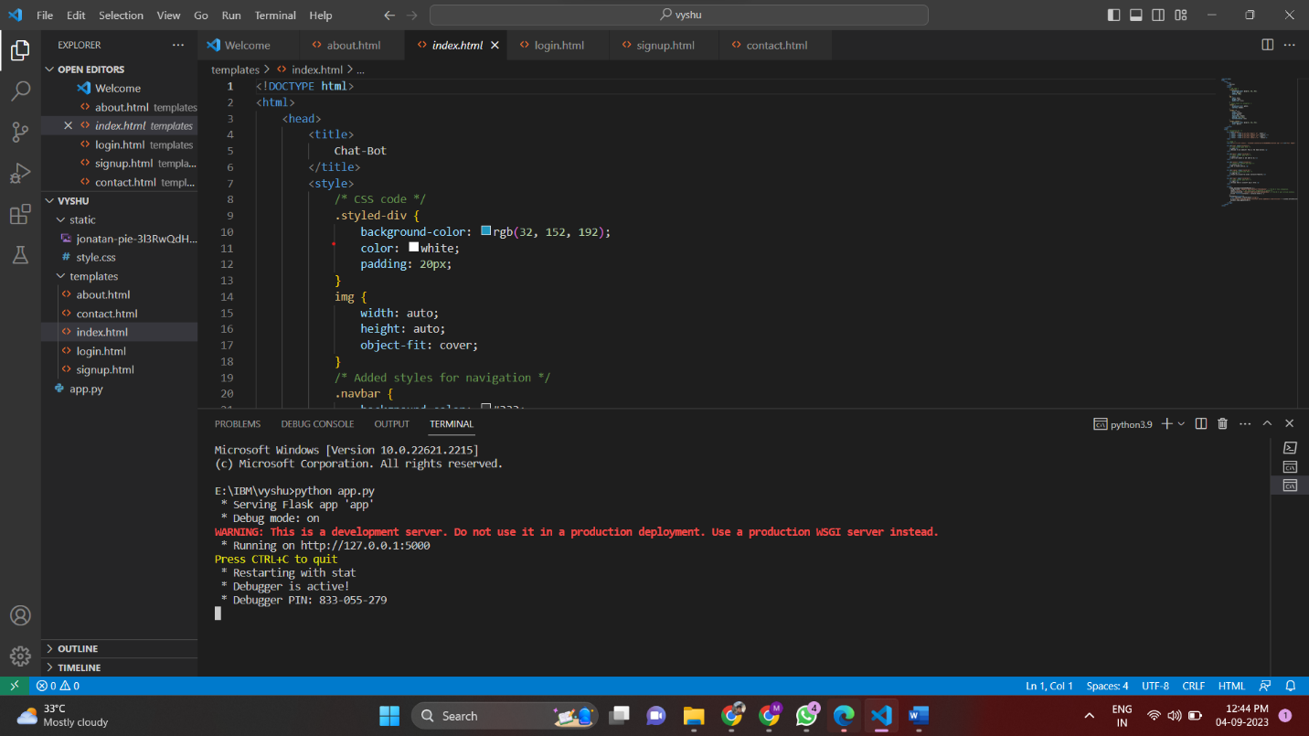

**Home page**

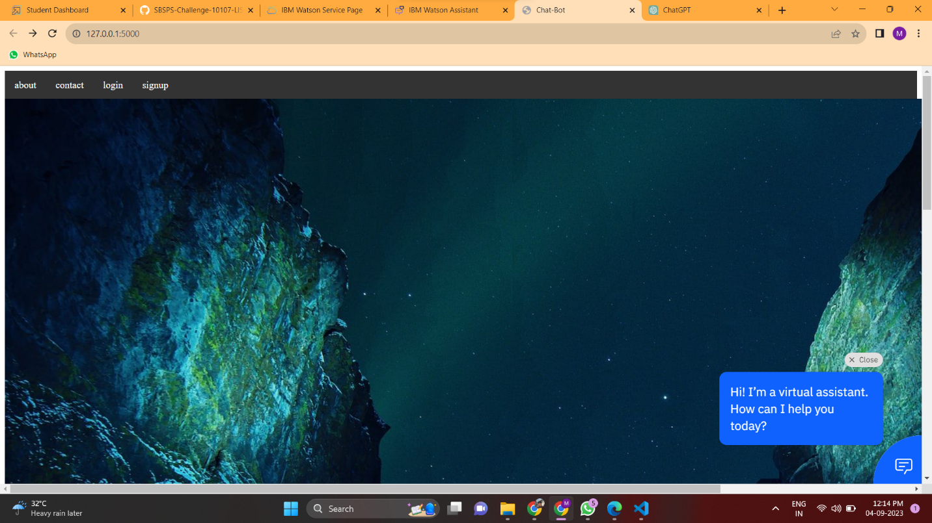

**About page**

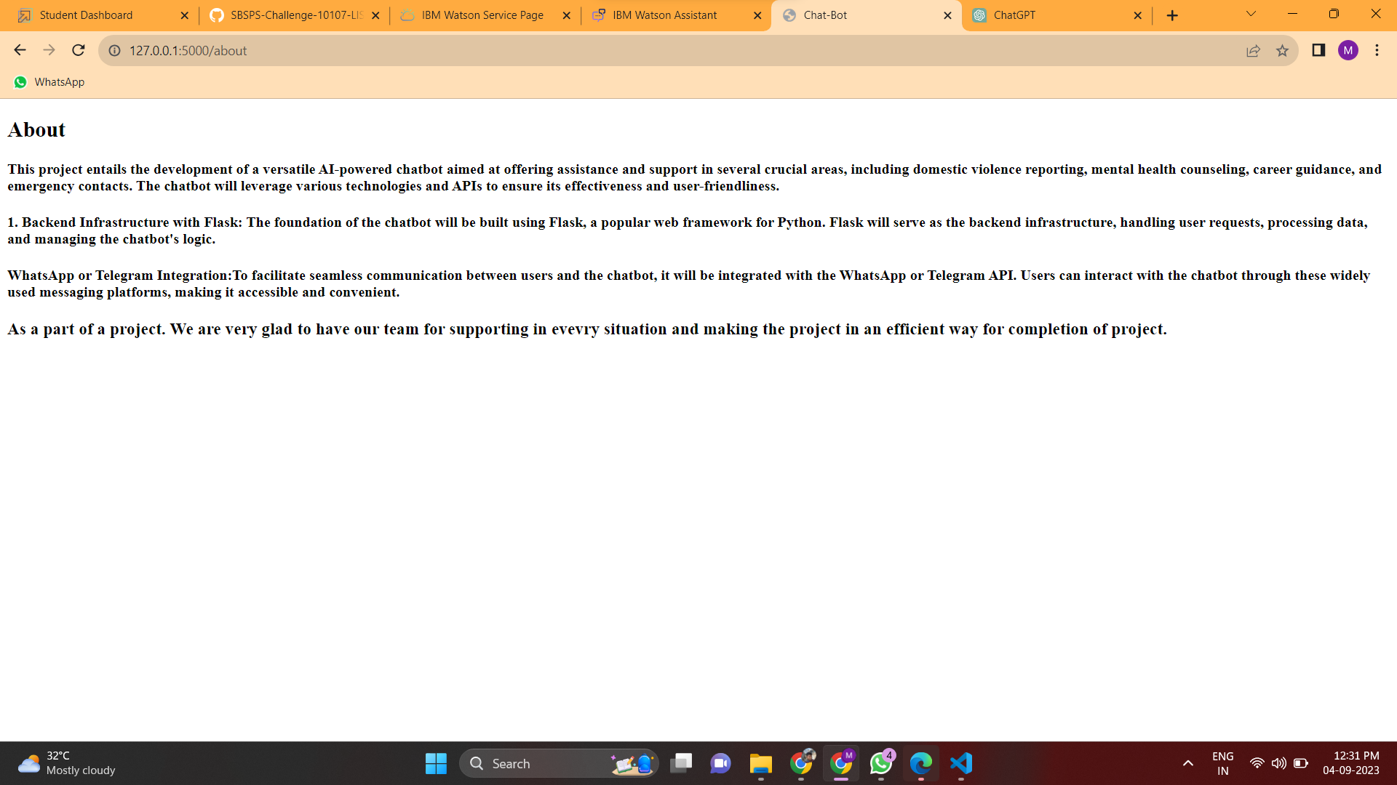

**Contact Us page**

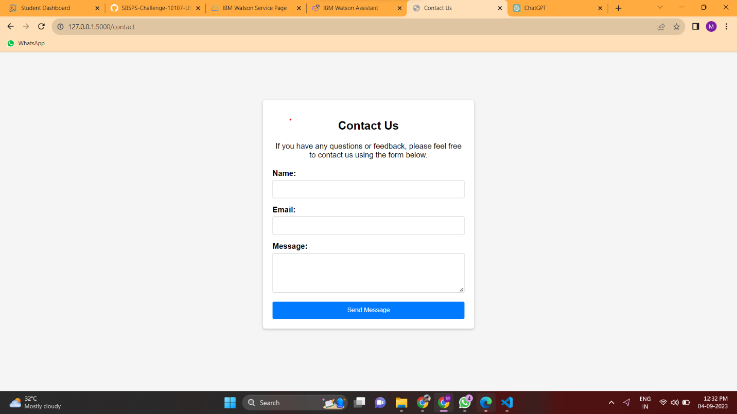

**Login Page**

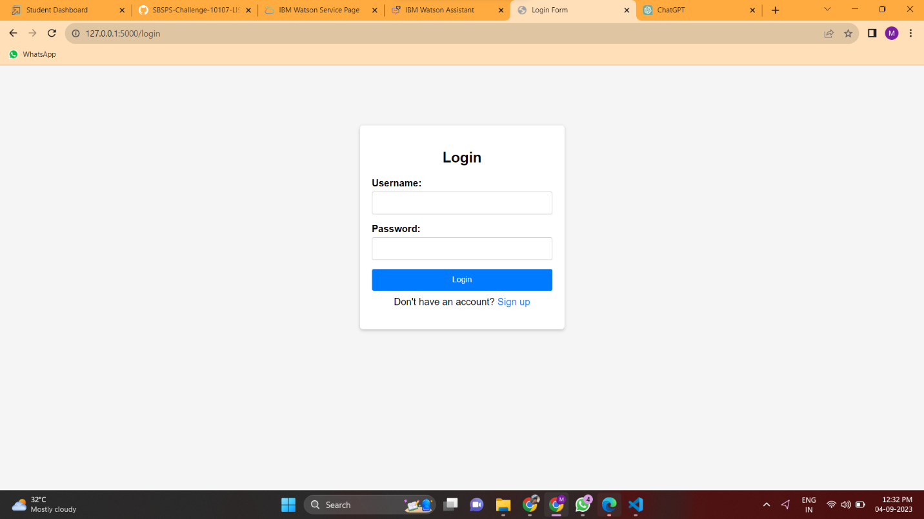

**Sign up Page**

